Assignment 3.1
Problem Statement

1. As voters exit the polls, you ask a representative random sample of 6 voters if they voted for
proposition 100. If the true percentage of voters who vote for the proposition is 55.1%, what is
the probability that, in your sample, exactly 2 voted for the proposition and 4 did not?
Ans:
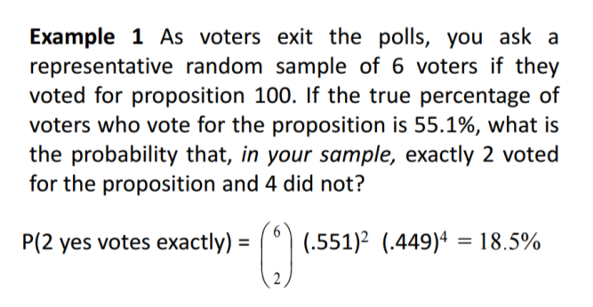
2. Professor Willoughby is marking a test.
Here are the students’ results (out of 60 points):
20, 15, 26, 32, 18, 28, 35, 14, 26, 22, 17
Most students didn't even get 30 out of 60, and most will fail.
The test must have been really hard, so the Prof decides to standardize all the scores and only fail people 1 standard deviation below the mean. So who will fail?

Ans:
Only two students will fail (the ones who scored15 and 14 on the test)
Mean -23
Standard Deviation -6.6

